A Domain Enriched Deep Learning Approach to

Classify Atherosclerosis Using Intravascular Ultrasound Imaging血管内超声成像用于动脉粥样硬化分类的领域丰富的深度学习方法

Max L. Olender[*,*](https://orcid.org/0000-0002-0936-5300) *Member, IEEE*, Lambros S. Athanasiou[,](https://orcid.org/0000-0002-8029-1332) Lampros K. Michalis[,](https://orcid.org/0000-0001-8834-4462)

Dimitris I. Fotiadis[*,*](https://orcid.org/0000-0002-5987-9350) *Fellow, IEEE*, and Elazer R. Edelman

***Abstract*—Intravascular ultrasound (IVUS) imaging is widely used for diagnostic imaging in interventional cardiology. The detection and quantification of atherosclerosis from acquired images is typically performed manually by medical experts or by virtual histology IVUS (VH-IVUS) software. VH-IVUS analyzes backscattered radio frequency (RF) signals to provide a color-coded tissue map, and is the method of choice for assessing atherosclerotic plaque *in situ*. However, a significant amount of tissue cannot be analyzedinreasonable timebecausethemethodcanbeappliedjust once per cardiac cycle. Furthermore, only hardware and software compatible with RF signal acquisition and processing may be used. In this article, we present an image-based tissue characterization method that can be applied to entire acquisition sequences *post hoc* for the assessment of diseased vessels. The pixel-based method utilizes domain knowledge of arterial pathology and physiology, and leverages technological advances of convolutional neural networks to segment diseased vessel walls into the same tissue classes as virtual histology using only grayscale IVUS images. The method was trained and tested on patches extracted from VH-IVUS images acquired from several patients, and achieved overall accuracy of 93.5% for all segmented tissue. Imposing physically-relevant spatial constraints driven by domain knowledge was key to achieving such strong performance. This enriched approach offers capabilities akin to VH-IVUS without the constraints of RF signals or血管内超声(IVUS)成像在介入心脏病学中被广泛用于诊断成像。从采集的图像中检测和量化动脉粥样硬化通常由医学专家或虚拟组织学IVUS(VH-IVUS)软件手动执行。VH-IVUS分析背向散射射频(RF)信号以提供颜色编码的组织图，是原位评估动脉粥样硬化斑块的首选方法。然而，大量的组织不能在合理的时间内进行分析，因为该方法在每个心脏周期只能应用一次。此外，仅可以使用与RF信号采集和处理兼容的硬件和软件。在这篇文章中，我们提出了一种基于图像的组织描述方法，该方法可以应用于事后的整个采集序列来评估病变血管。这种基于像素的方法利用动脉病理学和生理学领域的知识，利用卷积神经网络的技术进步，仅使用灰度IVUS图像将病变血管壁分割成与虚拟组织学相同的组织类别。该方法在从多个患者的VH-IVUS图像中提取的斑块上进行训练和测试，对所有分割的组织获得了93.5%的总体准确率。施加由领域知识驱动的物理相关的空间约束是实现如此强大性能的关键。这种增强的方法提供了类似于VH-IVUS的能力，而不受RF信号的限制**

|  |
| --- |
| Manuscript received December 15, 2019; revised May 1, 2020; accepted June 9,2020.DateofpublicationJune15,2020;dateofcurrentversionSeptember24, 2020. This work was supported in part by the U.S. National Institutes of Health under Grant R01 49039 awarded to Elazer R. Edelman and in part by a NVIDIA GPU Corporation Grant awarded to Lambros S. Athanasiou. The guest editor coordinating the review of this manuscript and approving it for publication was Prof. Arrate Munoz-Barrutia. *(Corresponding author: Max L. Olender.)*  Max L. Olender is with the Department of Mechanical Engineering and the Institute for Medical Engineering and Science, Massachusetts Institute of Technology, Cambridge, MA 02139 USA (e-mail: molender@mit.edu). Lambros S. Athanasiou and Elazer R. Edelman are with the Institute for Medical Engineering and Science, Massachusetts Institute of Technology, Cambridge,MA02139USA,andalsowiththeCardiovascularDivision,Brighamand Women’s Hospital, Harvard Medical School, Boston, MA 02115 USA (e-mail: lmathanas@gmail.com; ere@mit.edu).  Lampros K. Michalis is with the Faculty of Medicine, School of Health Sciences, University of Ioannina and the 2nd Department of Cardiology, University Hospital of Ioannina, 45500 Ioannina, Greece (e-mail: lmihalis@cc.uoi.gr). Dimitris I. Fotiadis is with the Unit of Medical Technology and Intelligent Information Systems, Dept. of Materials Science and Engineering, University of Ioannina, and the Dept. of Biomedical Research, Institute of Molecular Biology and Biotechnology - FORTH, GR 45110 Ioannina, Greece (e-mail: fotiadis@uoi.gr).  This paper has supplementary downloadable material available at https://ieeexplore.ieee.org, provided by the author. The material includes additional information on the materials and methods, dataset, and results. Contact molender@mit.edu for further questions about this work.  Digital Object Identifier 10.1109/JSTSP.2020.3002385 |

**limited once-per-cycle analysis, offering superior potential information acquisition speed, reduced hardware and software requirements, and more widespread applicability. Such an approach may well yield promise for future clinical and research applications.**

***Index Terms*—Atherosclerosis, intravascular ultrasound (IVUS), convolutional neural networks, deep learning, plaque characterization.**

# I. INTRODUCTION

**A**

THEROSCLEROSIS is an inflammatory disease which scleroses and obstructs flow through arterial blood vessels [1], [2]. Atherosclerotic plaques composed of lipids, inflammatory cells, and calcium deposits form in the vessel wall and ultimately impinge on the lumen, reducing distal perfusion. Tissue insufficiency that follows causes diseases that are the leading cause of morbidity and mortality globally [3]. 动脉粥样硬化是一种炎症性疾病，它使血管硬化并阻碍其流动[1]、[2]。动脉粥样硬化斑块由脂质、炎性细胞和钙沉积组成，形成于血管壁，最终冲击管腔，减少远端灌注。随之而来的组织不足导致的疾病是全球发病率和死亡率的主要原因[3]。

A primary step in diagnosing and treating atherosclerosis is imaging the arterial vessel wall. Though several techniques can visualizethelumenborderandroughlyascertaintheconstitution of the arterial wall, intravascular imaging is the current method of choice in interventional cardiology [4]–[6]. Intravascular ultrasound (IVUS) is an invasive technique which provides twodimensional (2D) tomographic views of the coronary lumen and vesselwall,allowingcomprehensivevisualizationofanyplaque. Generated images can provide reliable geometric measurements and estimates of plaque composition [7]. A well-trained expert canmanuallydeterminethedimensionsofthelumenandmediaadventitia border. Together these delineate the limits of the arterial wall and primary region of interest (ROI), as well as four different plaque constituent types: dense calcium (DC), necrotic core (NC), fibrotic tissue (FT), and fibro-fatty tissue (FFT) [8], [9]. DC is composed of compact calcium crystals, while NC consists of high levels of lipids with many necrotic cells. While both FT and FFT include collagen fibers, the former is mainly bundles of fibers [10], and the latter loosely packed fibers with lipid accumulations [11]. Due to their varying composition, each plaque type has unique echoreflectivity characteristics and consequently differentiable appearance within an IVUS image. 诊断和治疗动脉粥样硬化的首要步骤是对动脉血管壁进行成像。虽然有几种技术可以显示管腔边界并大致确定动脉壁的构成，但血管内成像是目前介入心脏病学的首选方法[4]-[6]。血管内超声(IVUS)是一种有创技术，它可以提供冠脉管腔和血管壁的二维(2D)断层图像，使任何斑块都能全面可视化。生成的图像可以提供可靠的斑块组成的几何测量和估计[7]。训练有素的专家可以手动确定管腔和中层外膜边界的尺寸。这些共同描绘了动脉壁和主要感兴趣区(ROI)的界限，以及四种不同的斑块组成类型：致密钙(DC)、坏死核心(NC)、纤维组织(FT)和纤维脂肪组织(FFT)[8]、[9]。DC由致密的钙晶体组成，NC由高水平的脂质和大量坏死细胞组成。虽然FT和FFT都包括胶原纤维，但前者主要是纤维束[10]，后者是松散堆积有脂质的纤维[11]。由于它们的组成各不相同，每种斑块类型都具有独特的回波反射率特征，因此在IVUS图像中具有不同的外观。

Manual ROI and tissue detection has been used since the introduction of IVUS. However, acquisition sequences can contain several thousand individual frames (images) [7], so manual processing is time-consuming and laborious. It is also subject to high inter- and intra-observer variability [12]. Moreover,

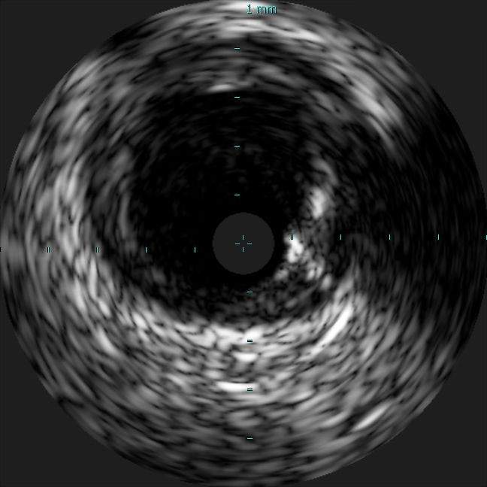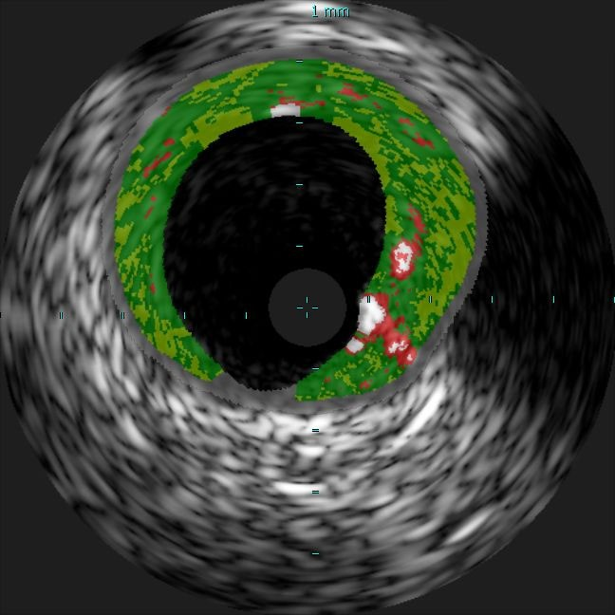

(a) (b)

Fig. 1. Sample VH-IVUS frame: (a) Grayscale IVUS image and (b) the same image overlaid with plaque types characterized by VH as dense calcium (DC; white), necrotic core (NC; red), fibrotic tissue (FT; green), fibro-fatty tissue (FFT; light green), and media or non-pathological tissue (M; gray).

discrimination of FT from FFT is limited, since the two plaques share similar characteristics. These limitations led to the development of automated ROI detection algorithms [13]–[18] and methods to segment tissue within the arterial wall [4]. 自从引入IVUS以来，一直使用手动ROI和组织检测。然而，采集序列可能包含数千个单独的帧(图像)[7]，因此手动处理既耗时又费力。它还受到观察者间和观察者内高度可变性的影响[12]。此外，FT和FFT的区别是有限的，因为这两个斑块具有相似的特征。这些限制导致了自动ROI检测算法[13]-[18]和分割动脉壁内组织的方法的发展[4]。

Numerous plaque characterization methods using IVUS images have been reported in the literature. The majority of these methods is based on machine learning approaches. The first methodology was presented by Zhang *et al.* [19], who automatically extracted image texture features and classified pixels using a learned piecewise linear discrimination function. Since then, many have followed, using different feature sets and classificationalgorithms[20],[21].Suchmethodsfollowthesamegeneral pattern: grayscale images are used as input and pixels are classified by a machine learning algorithm according to the pixels’ intensitiesandimagingcharacteristics(e.g.acousticshadows)or a supplementary set of extracted texture and geometric features. The gold standard for those methods was human expert manual annotations, which limited the amount of available data and suffered from inter- and intra-observer variability; subsequent implementation of the methods in clinical practice was hindered in part because validation and training relied upon such manual annotations. Therefore, Taki *et al.* [22], [23] – followed by others [24]–[26] – proposed similar machine learning approaches trained and validated using the results of a commercially available software: virtual histology (VH) IVUS [11]. 文献中报道了许多使用IVUS图像表征斑块的方法。这些方法中的大多数都是基于机器学习的方法。第一种方法是由Zhang et al.[19]提出的，他自动提取图像纹理特征，并使用学习的分段线性判别函数对像素进行分类。从那时起，许多人纷纷效仿，使用不同的特征集和分类算法[20]、[21]。这些方法遵循相同的一般模式：使用灰度图像作为输入，并且通过机器学习算法根据像素的强度和成像特征(例如声学阴影)或一组提取的纹理和几何特征的补充来对像素进行分类。这些方法的黄金标准是人类专家手册注释，这限制了可用的数据量，并受到观察者间和观察者内部变异性的影响；随后这些方法在临床实践中的实施受到阻碍，部分原因是验证和培训依赖于这种手动注释。因此，Taki et al.。[22]，[23]--紧随其后的是其他[24]-[26]--提出了类似的机器学习方法，并使用一种商用软件：虚拟组织学(VH)IVUS的结果进行了训练和验证[11]。

VH-IVUS was introduced to surmount the limitations of manual labeling of diseased vessels [11]. VH-IVUS offers a color-coded plaque characterization map, often overlaid on the corresponding grayscale image (Fig. 1). By processing the frequency spectrum of backscattered radiofrequency (RF) signal [27], rather than just the reflected signal amplitude, a more detailed assessment of the plaque can be generated with high accuracy confirmed through histology validation [8], [11], [28]– [30]. VH-IVUS can classify plaque into its four subtypes [11], andtreatsthenon-pathologicaltissueandmedia–theconcentric layer separating the disease-prone intima from the outer adventitia layer – as a separate combined class (M). The technology is the current gold standard for *in vivo* and *in situ* examination of coronary arteries [8], [11]. Although VH-IVUS provides relatively accurate plaque characterization, its main disadvantage is the fact that it requires acquisition of RF signal and proprietary software to process this signal. As a consequence, the plaque composition of grayscale IVUS frames acquired without the full RF signal (or without the proprietary software) cannot be characterized by this technique. Moreover, the RF signal is available only in the ECG-gated R-peak IVUS frames [31] – ∼1 of every 30 frames – resulting in significant information loss and large segments of uncharacterized vessel. Thus, methods able to characterize the plaque in a similar manner as VH-IVUS using grayscale methods remain attractive and highly relevant. VH-IVUS的引入是为了克服人工标记病变血管的限制[11]。VH-IVUS提供颜色编码的斑块特征图，通常覆盖在相应的灰度图像上(图1)。通过处理背向散射射频(RF)信号的频谱[27]，而不仅仅是反射信号的幅度，可以产生更详细的斑块评估，并且通过组织学验证[8]、[11]、[28]-[30]证实是高精度的。VH-IVUS可以将斑块分为四种亚型[11]，并将非病理组织和中膜--将易患疾病的内膜与外膜层分开的同心层--视为一个单独的组合类别(M)。这项技术是目前活体和原位检查冠状动脉的金标准[8]、[11]。虽然VH-IVUS提供了相对准确的斑块特征，但它的主要缺点是需要采集射频信号和专有软件来处理该信号。因此，在没有完整RF信号(或没有专有软件)的情况下获取的灰度IVUS帧的斑块组成不能用这种技术来表征。此外，RF信号仅在心电门控R峰静脉内超声帧[31]-每30帧的1帧中可用，导致显著的信息丢失和大段未定性血管。因此，能够以与VH-IVUS相似的方式使用灰度方法来表征斑块的方法仍然具有吸引力和高度相关性。

Recent developments in deep learning and convolution neural networks (CNN) have made possible characterization tools in different imaging modalities which outperform methods deploying traditional machine learning or image processing [32]. Indeed,noneoftheexistingIVUSplaquecharacterizationmethods, which require explicit feature set design, selection, and extraction through pre-processing, have achieved overall label assignment accuracy *>*90% [4] (Table III). To date, however, deep learning has been applied to IVUS only for delineating inner and outer boundaries of the arterial wall (i.e. ROI) [17], [18] and to select frames containing calcification [33]; no method has applied CNNs to grayscale IVUS imaging data to improve plaque characterization and generate information akin to VH-IVUS. 深度学习和卷积神经网络(CNN)的最新发展使不同成像模式下的表征工具成为可能，这些工具的性能优于采用传统机器学习或图像处理的方法[32]。事实上，现有的IVUS斑块表征方法中，没有一种需要明确的特征集设计、选择和通过预处理提取的方法，其总体标签分配准确率都不超过90%[4](表III)。然而，到目前为止，深度学习仅应用于IVUS，仅用于描绘动脉壁的内外边界(即ROI)[17]、[18]以及选择包含钙化的帧[33]；还没有方法将CNN应用于灰度IVUS成像数据以改善斑块特征并生成类似于VH-IVUS的信息。

We present a novel CNN-based domain enriched method that classifies arterial tissue imaged through IVUS. The method detectstheROIusingrecentlydeveloped software[34],andthen subdividestheROIintopathologicalandnon-pathologicaltissue based upon basic spatial and geometric constraints informed by physiology. Pathological areas of the ROI are partitioned into patchesandfedthroughaCNNarchitecture.CorrespondingVHIVUS images serve as the comparative control. The proposed method offers several meaningful benefits stemming from its independence from the RF signal data, which increases the clinicalutilityandresearchapplicabilityofthemethod.Inparticular, the method can be applied to grayscale IVUS data, including previously-acquired images that have not been characterized by the VH technique due to a lack of RF signal or proprietary software, or to intermediate frames of VH-IVUS acquisitions betweenECG-gatedframes,therebyincreasingtheeffectiverate at which meaningful information on plaque morphology can be attained and reducing procedure time. 我们提出了一种新的基于CNN的领域丰富方法，该方法通过IVUS对动脉组织进行分类。该方法使用最近开发的软件检测ROI[34]，然后根据生理学提供的基本空间和几何约束将ROI细分为病理性和非病理性组织。ROI的病理性区域被分割成补丁，并通过CNN架构馈送。相应的VHIVUS图像作为对照。由于不依赖于射频信号数据，该方法提供了几个有意义的好处，从而增加了该方法的临床实用性和研究适用性。具体地说，该方法可以应用于灰度IVUS数据，包括由于缺乏RF信号或专有软件而未由VH技术表征的先前采集的图像，或者应用于ECG门控帧之间的VH-IVUS采集的中间帧，从而提高可获得关于斑块形态的有意义信息的有效率并减少手术时间。

# II. MATERIALS AND METHODS

Theproposedautomatedplaquecharacterizationmethodconsists of three steps (Fig. 2). The ROI is first detected, then pathological tissue is partitioned from the rest of the vessel wall (M) based upon domain knowledge of spatial constraints imposed by arterial physiology and pathology. This process imposes physically-relevant limits on the location and dimensions of this tissue class while also reducing the number of classes to be subsequently segmented by the CNN. In the final step, pixels of the ROI in the pathological area are classified into one of the four plaque types. To investigate the utilityof leveraging domain enrichment, an equivalent “naïve” method was implemented where non-pathological tissue was not first segmented from the pathological tissue prior to CNN segmentation, but was instead

|  |
| --- |
| Fig. 2. Flowchart of the plaque characterization method enriched by domain knowledge. The naïve method does not segment the non-pathological tissue and media based upon vascular physiology and pathology constrains, but rather inputs the full ROI to the CNN, which must segment the image into all 5 classes.丰富领域知识的斑块表征方法流程图。朴素的方法不是基于血管生理和病理约束来分割非病理组织和介质，而是将完整的ROI输入到CNN，CNN必须将图像分割成所有5类。 |

segmented as a fifth class. The method was implemented in MATLAB (MathWorks, Natick, MA) using the Deep Learning Toolbox running on a NVIDIA TITAN Xp GPU (PG611) with 12 GB RAM. 所提出的自动斑块表征方法包括三个步骤(图2)。首先检测ROI，然后基于动脉生理和病理施加的空间约束的领域知识将病变组织与血管壁(M)的其余部分分开。这一过程对该组织类别的位置和尺寸施加了物理上的相关限制，同时也减少了随后被CNN分割的类别的数量。最后，将病变区域的ROI像素分类为四种斑块类型中的一种。为了研究利用结构域丰富的效用，我们实施了一种等效的“幼稚”方法，在CNN分割之前，没有首先从病变组织中分割出非病变组织，而是将其作为第五类分割。该方法是在MA TLAB(MathWorks，Natick，MA)中使用运行在具有12 GB RAM的NVIDIA Titan XP GPU(PG611)上的深度学习工具箱实现的。

## A. Region of Interest

The region between the lumen border and the mediaadventitia border where atherosclerotic plaques develop was denotedastheROI.ROIsegmentationisaprerequisiteforsubsequent methodological steps, though succeeding procedures are agnostic to ROI segmentation approach, method, or algorithm (of which there are a large and growing number). To detect the ROI in each frame, we here utilized a previously validated method [13] recently incorporated into a user-friendly software suite [34]. In brief, initial contours for the lumen and mediaadventitia borders are estimated using basic image processing: the image is binarized using Otsu’s automatic thresholding algorithm [35], and the tentative borders are found by scanning radial projections for binary state transitions. The method subsequently refines the borders using active contour models [36]. Within each IVUS image *I*(*i,j*), the lumen border *bl*(Θ) and media-adventitia border *bma*(Θ) fully delineate the ROI (intima and media region) *rim*(*irim,jrim*). 动脉粥样硬化斑块形成的管腔边界和中层外膜边界之间的区域称为ROI。ROI分割是后续方法论步骤的先决条件，尽管后续步骤与ROI分割途径、方法或算法(其中有大量且不断增长的算法)无关。为了检测每一帧中的ROI，我们在这里使用了一种先前经过验证的方法[13]，该方法最近集成到了一个用户友好的软件套件[34]中。简而言之，使用基本图像处理来估计管腔和中层外膜边界的初始轮廓：使用Otsu的自动阈值算法对图像进行二值化[35]，并通过扫描径向投影来寻找二进制状态转换的暂定边界。该方法随后使用活动轮廓模型来细化边界[36]。在每个IVUS图像I(i，j)内，管腔边界b1(Θ)和中膜-外膜边界bma(Θ)完全描绘了ROI(内膜和中膜区域)边界*rim*(*irim,jrim*)。

## B. Pathological Tissue Detection

The proposed method focuses on the evaluation of vessel wall morphology and the characterization of its phenotype, distinguishing not only plaque subtype but normal from pathological tissue.ThisconcepthasalreadybeenimplementedinVH-IVUS, where each tissue type is highlighted as a specific color and the media portrayed in gray along the rim of the vessel wall (Fig. 1). Physical and dimensional limits were imposed herein, leveraging expert recommendations for interpreting intravascular images; intima was deemed normal if its thickness was *<*360 *μ*m, and the media was assumed have nominal thickness of 250-350 *μ*m [31], [37], [38]. Thus, the location and thickness of non-diseased and media tissue was defined such that wall regions thinner than threshold were not to be considered diseased or analyzed as such, and the media layer approximated by a band of constant thickness around the outer edge of the ROI. Though media thickness does vary somewhat, its range is largely negligible relative to that of the inner intima layer, and is furthermore at the horizon of VH-IVUS imaging resolution (100–200 *μ*m) [7], [9], [31]. 该方法侧重于评价血管壁的形态和表型特征，不仅区分斑块亚型，而且区分正常和病理组织。这一概念已经在VH-IVUS中实现，其中每种组织类型突出显示为特定的颜色，而沿血管壁边缘的介质用灰色描绘(图1)。这里施加了物理和尺寸限制，利用专家的建议来解释血管内图像；如果内膜厚度<360μm，则认为内膜正常，并假定中膜的标称厚度为250-350μm[31]、[37]、[38]。因此，定义了非病变组织和介质组织的位置和厚度，使得壁薄于阈值的区域不会被认为是病变或分析为病变区域，并且介质层由围绕ROI外缘的恒定厚度的带近似。虽然中层厚度确实有一些变化，但相对于内膜层，中层厚度的范围可以忽略不计，而且还在VH-IVUS成像分辨率(100200μm)[7]、[9]、[31]的水平上。

To determine the normal wall and the media layer locations and dimensions, two geometrical parameters were computed for each pixel in the ROI: 为了确定正常壁和介质层的位置和尺寸，对ROI中的每个像素计算了两个几何参数：

|  |  |
| --- | --- |
| *Dthick* = *D*1 + *D*2*,*and | (1) |
| *Douter* = *D*1*,* | (2) |

where *D*1 and *D*2 are the Euclidian distances of the pixel (*irim,jrim*)fromthemedia-adventitiaborder*bma* andthelumen border *bl*, respectively (Fig. 3 and Fig. S1). 其中D1和D2分别是像素(*irim,jrim*)到中膜-外膜边界bm和管腔边界b1的欧几里得距离(图3和图3)。S1)。Threshold values for *Dthick* and *Douter* were calculated to determine whether a pixel was in a section of sufficient thickness to be considered pathological or sufficiently close to the media-adventitia border toliewithinthemedia. All*Ntot* VH-IVUSimages andtheirROI pixels that belong to the media or non-pathological class (M, gray color; *rimM* ) were considered. The pathological thickness threshold was calculated as the maximum *rimM* section thickness immediately adjacent to the lumen (*bl*): 计算Dthick和Douter的阈值，以确定像素是否在厚度足以被认为是病理性的部分，或者是否足够靠近中膜-外膜边界而位于中膜内。考虑所有Ntot VH-IVUS图像及其ROI像素属于中膜或非病理类别(M，灰色；*rimM*)。病理厚度阈值计算为紧邻管腔的最大*rimM*断面厚度(bl)：

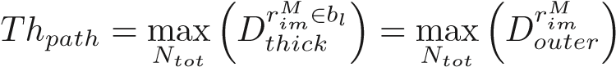 *.* (3)

The maximum media thickness threshold was calculated as the minimum thickness of *rimM* sections in which pathological tissue is present (i.e. *Dthick* ≥ *Thpath*): 最大介质厚度阈值计算为存在病变组织的*rimM*图像的最小厚度(即Dthick≥Thpath)：

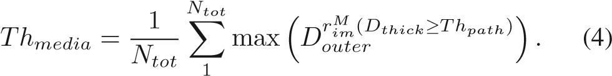

*Thpath* was 30 pixels, and *Thmedia* was 11 pixels. Pixels of the ROI were classified as pathological tissue (ROIpath) if

*Douter* ≥ *Thmedia* and *Dthick* ≥ *Thpath* (Fig. 3).

This pathological tissue detection procedure is the primary mechanism by which domain knowledge enriched learning to address the image classification problem. Following this step, classification was only required for the four remaining tissue types. For the naïve method developed to assess the importance of this contribution, this step was not completed; instead, subsequent classification routines were taught to detect this tissue type directly from the image patch data. 这一病理组织检测过程是领域知识丰富学习解决图像分类问题的主要机制。在此步骤之后，只需要对剩余的四种组织类型进行分类。对于为评估这一贡献的重要性而开发的幼稚方法，这一步没有完成；相反，随后的分类例程被教导直接从图像补丁数据中检测这种组织类型。

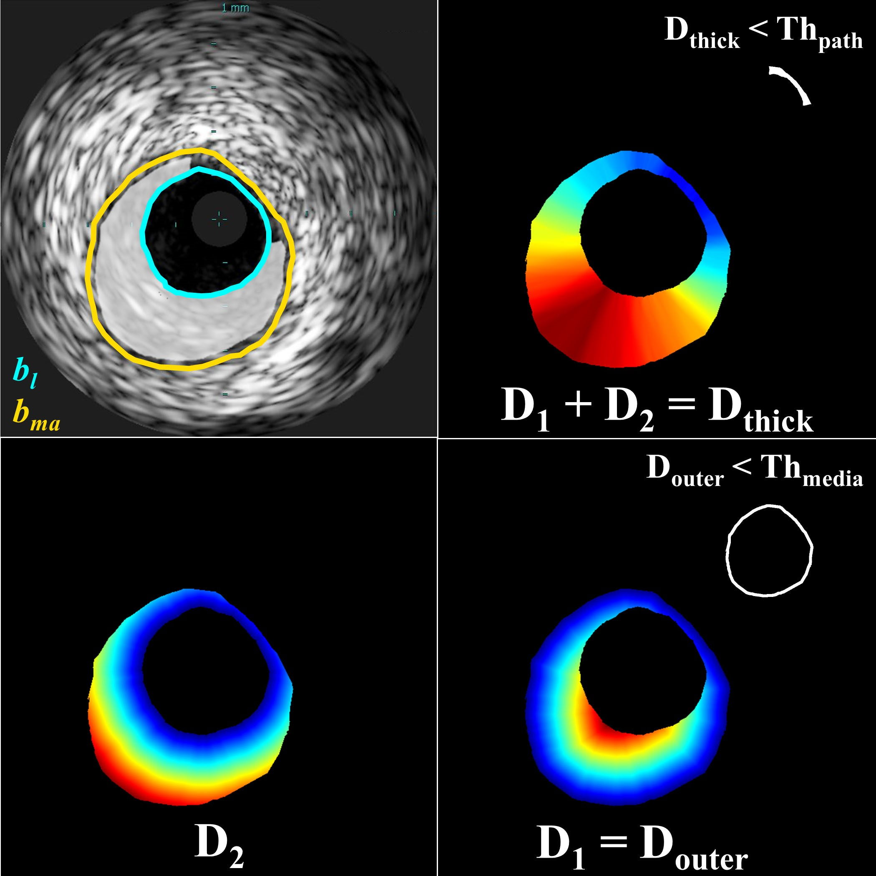

Fig. 3. Schematic presentation of the pathological tissue segmentation. Given borders of the lumen (*bl*) and media-adventitia (*bma*; *top left*), Euclidean distances from a pixel (adventitia border (*D*1)*r*were calculated*im* ∈ ROI) to the lumen border(*bottom*). Pixels within the ROI for(*D*2) and the media-

which *Douter <Thmedia* and *Dthick <Thpath* correspond to media and non-pathological tissue, respectively (*right*, inset). Other pixels within the ROI correspond to pathological tissue (ROIpath; *top left*, highlighted). Color in distance maps indicates relative magnitude of values (blue: small, red: large).

## C. Classification

For the domain enriched method, pixel-centered patches were created for remaining pixels of the ROI after segmenting the M class (*rim* ∈ ROI*path*), then automatically classified into one of the four plaque types using a CNN. For the naïve method, patches were created for all pixels of the ROI (*rim* ∈ ROI) and sorted into one of the five tissue types by the classifier. 对于区域丰富的方法，在分割M类(*rim* ∈ ROI*path*)后，为感兴趣区域的剩余像素创建以像素为中心的斑块，然后使用细胞神经网络将其自动分类为四种斑块类型中的一种。对于朴素的方法，为感兴趣区域(*rim* ∈ ROI*path*)的所有像素创建补丁，并由分类器将其分类为五种组织类型之一。

*1) CNN Algorithm:* CNNs are a class of deep neural networks [39] commonly applied to image classification because they can leverage spatial locality and translational invariance to dramatically reduce the number of weighted network connections requiring optimization (cf. fully-connected neural networks). Their architecture can be described by multiple layers, which can be categorized as input, output, or hidden. The input layer here receives the 2D (grayscale) image patch, the hidden layersareformedbymultiplefunctionallayersinwhichthecompound image features are calculated and strategically pooled, and the output layer is the classification result. Combined in series, such a CNN can be represented by a non-linear function, *P*(*I*;*θ*) = *pi*,which maps an image *I* ∈RH×H of *H* × *H* size to a vector *pi* = (*p*1*,p*2*,...,pc*)*T*. The probability of *I* belonging to one of target classes *i* = {1*,...,c*} is represented by *pi* ∈ [0*,*1], and *θ* = {*θ*1*,θ*2*,...,θ*K} are the *K* parameters (weights and biases) used to map *I*to *pi*. CNN training is an optimizationproblemforanon-linearfunctionwithmanydegreesof freedom:

*θ*ˆ= argmin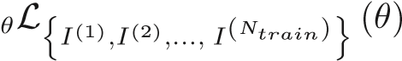*,* (5)

where L(*θ*) ∈ [0*,* 1] is a loss function and *Ntrain* is the number of training images.

Here, we used multiclass cross-entropy loss (also known as negative log likelihood), the most popular choice for probabilistic classification problems:

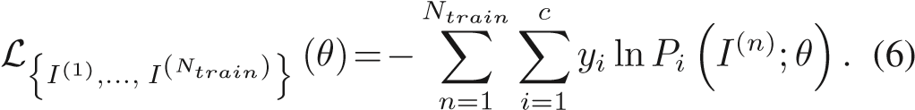

This loss function measures the performance of the classifier *P* relative to the binary class label vector *yi*.

To reduce the training time for the CNN, the stochastic gradient descent (SGD) iterative method was used. This method approximates the dataset with a subset of samples randomlydrawn from the full training dataset, called a mini-batch, and uses the gradient calculated for the mini-batch to update the model in each iteration. SGD is known to sometimes oscillate along the path of steepest descent (maximum gradient) towards the optimum, rather than directly along the path toward the optimum, since the gradient always points towards the opposite side of this optimum from the current position. A solution to this problem is the addition of a momentum term to the parameter update to reduce oscillations:

*θ*λ+1 = *θ*λ − *α*∇L(*θ*λ) + *γ* (*θ*λ − *θ*λ−1)*,* (7)

where λ is the iteration number, *α >* 0 is the learning rate, and the momentum term *γ* determines the contribution of the previous gradient step to the current iteration. Thus, the SGD algorithm selects a subset of the training set D*train*, evaluates the mean gradient of the loss function L for this minibatch, then updates the network parameters *θ*. Each evaluation is an iteration, and at each iteration the loss function is minimized further. The full pass of the training process over the whole training set, in mini-batch increments, forms an epoch.

In training the network described herein, a stochastic gradient descent with momentum optimizer was implemented with a constant learning rate (*α*) of 0.03 and momentum value (*γ*) of 0.9. A mini-batch size of 3,000 patches was utilized over 50 epochs; data were shuffled after each epoch. Weight decay (L2 regularization) by a factor of 0.0001 was used to reduce overfitting. Weights were initialized with a Glorot initializer, which independently samples from a uniform distribution centered around zero; biases were initialized to zero.

*2) CNN Architecture:* To classify the pixels corresponding to pathological tissue, a sequence of convolutions, activations, and pooling operations were executed. To achieve the best classification results, different patch sizes, numbers of input patch convolution sequences, filters, and filter sizes were tested. A patch size of 41 × 41 was determined to perform best through parameter sensitivity analysis (Fig. S6). The network found to perform best, and utilized in this work, is shown in Fig. 4 and Fig. S2 (Supplemental Materials). 为了对对应于病理组织的像素进行分类，执行了一系列卷积、激活和合并操作。为了获得最佳的分类结果，测试了不同的块大小、输入块卷积序列的数量、滤波器和滤波器大小。通过参数敏感性分析，确定41×41的斑块大小表现最好。(中六)。图4和图S2(补充材料)显示了在这项工作中使用的性能最好的网络。。

Fig.4. Progressivedataprocessing performedbythe26-layerCNNto classify pixels within the pathological region of interest. (See Fig. S2 in Supplemental

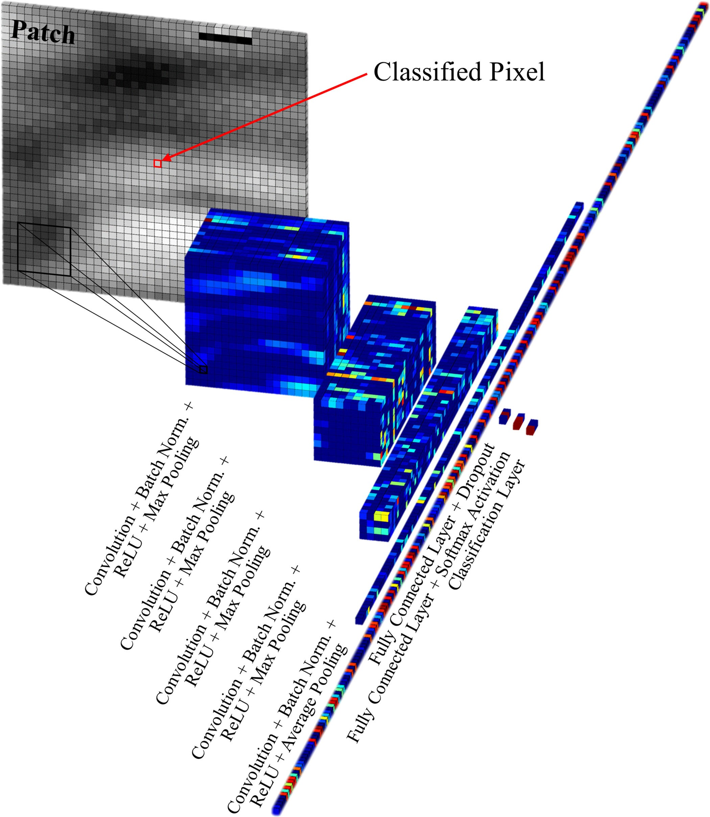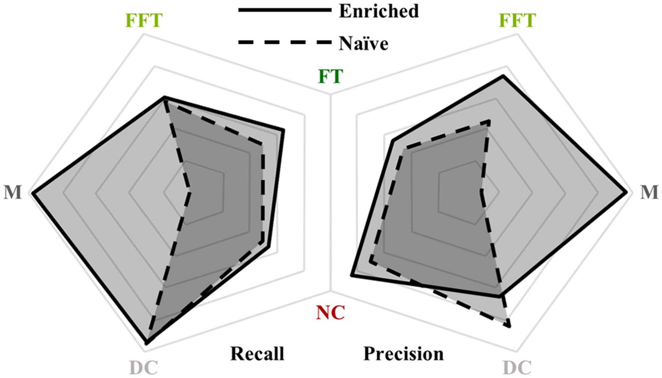

Fig.5.

Comparisonofrecall(i.e.sensitivity)andprecision(i.e.positive

predictivevalue)achievedbytheenrichedandnaïvemethods(shownwith

solidanddashedborders,respectively).Theenrichedmethoddemonstratesclear

superiority,particularly,butnotexclusively,incategorizingMclasstissue.Axes

rangefrom75%to100%(linearscalefromcentertoperimeter).

5

4

Materials for a detailed schematic of the CNN architecture.)

# TABLE I

DOMAIN ENRICHED: SPATIAL CONSTRAINTS + ROIpath SEGMENTATION

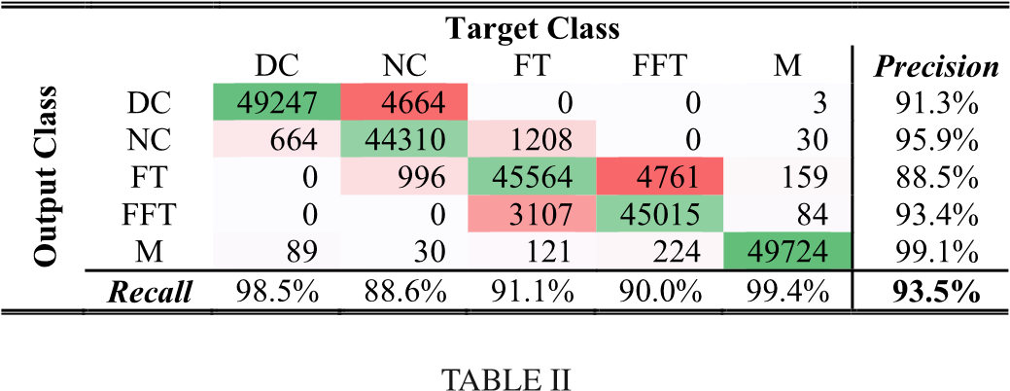

NAÏVE: FULL-ROI SEGMENTATION

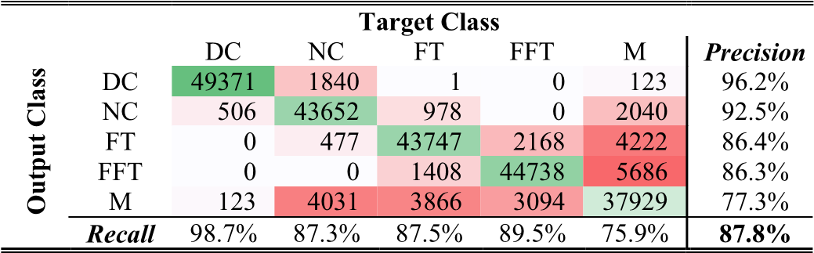

# III. DATASET

To train and test our plaque characterization algorithm, 553 VH-IVUSframesandthecorrespondinggrayscaleIVUSframes were acquired from eight patients. The data were acquired at 20 MHz using a 3.5 F electronic probe with synthetic aperture (Eagle Eye Gold Catheter, Philips Healthcare, Andover, MA), in accordance with clinical standards [7], [31]. From the dataset, 200 frames were withheld exclusively for testing while the remaining frames were sampled for training and validation. From this larger subset, equal numbers of 41-by-41 pixel patches (3.4×105) were randomly extracted for each of the fiveclasses, and data augmentation was performed through reflection and rotation in 90° increments. From the withheld testing subset, 5 × 104patches of each class were randomly selected from bulk regions of tissue for final testing and validation. Additional details on the dataset are available in the Supplemental Materials.为了训练和测试我们的斑块表征算法，从8名患者获得了553个VH-IVUS帧和相应的灰度IVUS帧。根据临床标准[7]，[31]，使用带有合成孔径的3.5F电子探针(鹰眼黄金导管，飞利浦医疗，马萨诸塞州安多弗)以20 MHz的频率采集数据。从数据集中保留200个帧专门用于测试，而对其余帧进行采样以进行训练和验证。从这个较大的子集中，为每一类随机提取相同数量的41x41像素斑块(3.4×105)，并以90°为增量通过反射和旋转来执行数据增强。从保留的测试子集中，从组织的大块区域中随机选择每个类别的5×104个贴片进行最终测试和验证。有关该数据集的更多详细信息，请参阅补充材料。

# IV. RESULTS

Image segmentation accurately replicating VH-IVUS classification was successfully achieved using only grayscale IVUS images, with the domain enriched method providing better results than the naïve one. Tables I and II provide the error (or confusion) matrices for the enriched and naïve methods, respectively, showing that the former achieved an overall accuracy of 93.5% and the latter 87.8%. Performance metrics by tissue class are summarized and compared in Fig. 5. 仅使用灰度IVUS图像就成功地实现了精确复制VH-IVUS分类的图像分割，域丰富的方法提供了比单纯的方法更好的结果。表I和表II分别给出了富集法和朴素法的误差(或混淆)矩阵，前者的总体准确率为93.5%，后者为87.8%。图5对按组织类别划分的性能指标进行了总结和比较。

Representative examples of classified images resulting from each method are shown in Fig. 6, with detailed regions shown in Fig. 7. Both methods accurately captured major tissue morphology and features within the pathological region (Fig. 6). However, the naïve method struggled to identify non-pathological and media tissue, and occasionally generated physiologically implausible configurations (Fig. 7). Due to the spatial constrainsimposedpriortoCNNclassification,thedomainenriched method addressed non-pathological and media tissue very accurately, and was not disposed to violating physiological constraints. It captured fine features and provided sharp distinctions between various plaque types; it generated images that are very similar to gold standard VH-IVUS.

Whilethenaïvemethodperformancemetrics(TableII)reflect only the five-class CNN classifier, as the classifier itself performs all segmentation operations, the overall domain enriched method metrics (Table I) depend both on (four-class) classifier performance and reliability of pathological tissue detection,

**Grayscale with Borders VH-IVUS**

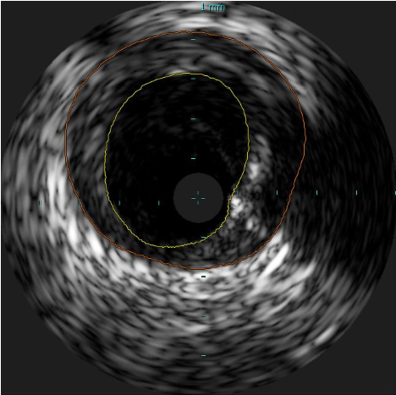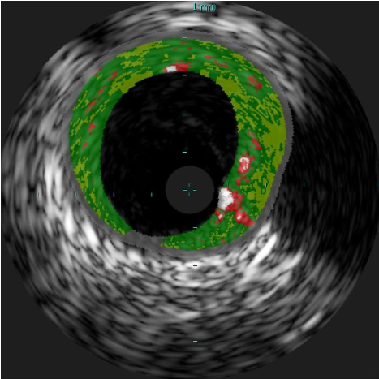

**Naïve Method Enriched Method**

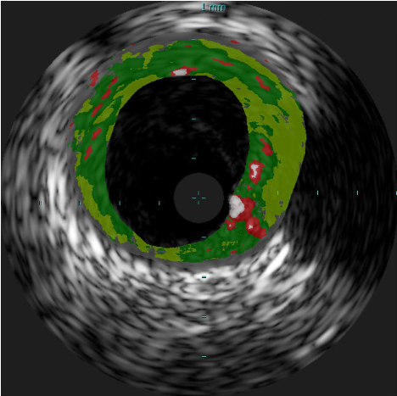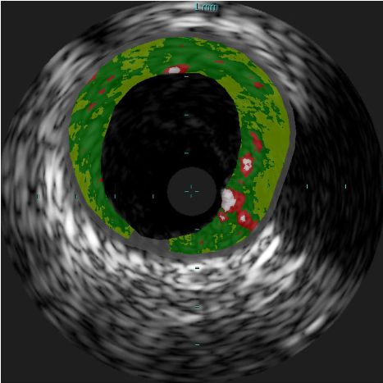

Fig. 6. Representative classified IVUS image segmented by VH-IVUS (ground truth), naïve method, and enriched method. Both presented methods identify major pathological tissue morphology features, but the naïve method misclassifies much of the non-pathological and media tissue. The enriched method provides somewhat sharper distinctions between various plaque types and consequently captures finer features, and is most similar to VH-IVUS.

which together share responsibility for the full segmentation procedure. The CNN classifiers, trained only on pixels classified by VH-IVUS, achieved generally high precision (i.e. positive predictive value) and recall (i.e. sensitivity). Table SI (in Supplemental Materials) shows the error matrices for the enriched method’s four-class CNN classifier – the model achieved an accuracy of 92.3% (cf. naïve five-class classifier accuracy of 87.8%, Table II). CNN training took several weeks (roughly 3 days per epoch for the 5-class model and somewhat less for the 4-class model). Training was halted once accuracy and loss plateaued, after no more than 50 epochs (Fig. S5); with further training, validation metrics deteriorated, indicating overfitting of the model to training data.

Error matrices of the classifiers illustrate some general and model-specific trends. Both classifiers – the five-class network supportingthenaïvemethodandthefour-classnetworksupporting the domain enriched method – struggle to differentiate FFT from FT and, unexpectedly, DC from NC. Notably, while class confusion trends were universally observed for both models, performancewasworseinallcasesforthe5-classCNNexceptin thetaskofidentifyingcalcium(DC).Furthermore,classification of the media by this model is only mediocre – pixels belonging to the M class are often misclassified as FT, FFT, or NC, and these tissues are conversely misclassified as M with moderate frequency.Thesefindingsshowthatimposingspatialconstraints to determine non-pathological and media tissue prior to CNN classification, and excluding this class from classification, not only improved segmentation of this non-diseased tissue type, but that of the classified plaque as well. However, the enriched model was still subject to compounding uncertainties arising frompathologicaltissuedelineation.Whiledelineationofpathological tissue, as defined by VH-IVUS, was very accurate, the CNN of the enriched method was incapable of classifying M tissue it encountered (and typically identified it as FT; Table SI).

Executiontimeofthecharacterizationmethodwasdominated by the pixel-wise network classification of the ROI. Each pixel took 7.4 ± 0.4 milliseconds (mean ± standard deviation) to classify, though this value was found to be very sensitive to the machine on which classification was performed. Each ROI contained 37801 ± 22455 pixels, of which the enriched method determined that 26776 ± 20805 pixels were pathological and subsequently classified by the network. (The naïve method classified all pixels within the entire ROI.) Calculation of *D1* and *D2*, and subsequent designation of the media and nonpathological tissue in a frame, took just 25.5 ± 0.9 milliseconds per frame. Because the ROI delineation method is considered interchangeable for this method, execution time of this step was not determined, but several methods report execution times significantly less than 1 second per frame [13], [14], [17], [18]. Consequently, characterization of full frames took 200 ± 150 seconds and 280 ± 170 seconds with the enriched and naïve methods,respectively.Therangeofexecutiontimescorresponds to the drastic variability in plaque content between frames; while segments with high plaque burden took several minutes to characterize, frames depicting cross-sections without diseased tissue (just media and/or non-pathological tissue) took just a fraction of a second for the enriched method. We note here that per-frame characterization time is reported for a scenario in which every individual pixel of the ROI is characterized, rather than a strategically selected subset, and furthermore neither software nor hardware were optimized for execution time. As such, these times should be interpreted as an upper bound.

Supplemental results, including those of a sensitivity analysis of patch size, as well as an ablation study of the enriched network’s CNN, are provided in the Supplemental Materials.

# V. DISCUSSION

The confluence of domain knowledge in vascular pathology and physiology and intravascular imaging, and advancements in machine learning, has enabled an enhanced deep learning approach to classify atherosclerosis using intravascular ultrasound grayscale images. This approach exceeds the performance of previously-reported methods for plaque segmentation in IVUS without the use of spectral signals [4], and produces maps of tissuemorphologythatcloselyresembleVH-IVUS.Ofgreatimportance, the method offers attributes that exceed those of VHIVUS. Because no RF (spectral) data are required, the method’s applicability isnot limited toECG-gated frames, but can be used to extract plaque morphologies in any grayscale IVUS image. To acquire the same lateral resolution of plaque morphology using VH-IVUS would require extensive procedural time; the method is also not subject to the loss of temporal resolution that limitsVH-IVUS[31].Furthermore,VH-IVUSoffersloweraxial spatial resolution than its grayscale counterpart [7], [9], [31], suggesting that a classification method based upon the grayscale

|  |
| --- |
| **(a) (b) (c) (d) (e)**  **Grayscale IVUS**  **VH-IVUS**  **Enriched Method**  **Naïve Method**  Fig. 7. Sample classified regions of IVUS images segmented by VH-IVUS (ground truth) and the two presented methods. Both presented methods identify major pathological tissue morphology features quite well, but the enriched method demonstrates clear superiority. In these examples, the naïve method misclassifies much of the non-pathological and media tissue and proposes several variations of physiologically non-feasible morphologies. These physiological impossibilities include islands of non-pathological tissue embedded within a diseased region (a–e), exaggerated, thick segments of healthy (normally-thin) intima or media tissue (c), and calcified and lipid deposits within exceptionally thin wall segments (a, b). Light blue hash marks within each image demarcate 1 mm increments. |

information alone could offer superior detail and information on fine features. All of these benefits are achieved without the need for specialized hardware or proprietary software.

The impact of leveraging domain knowledge to distinguish pathological from non-pathological tissue prior to CNN classification was assessed, and was found to offer substantial benefit. In particular, enforcing physiologically-imposed spatial constraints to assign the non-pathological and media tissue class not only improved classification performance for this class, but also benefited classification of the remaining pathological tissue types and decreased execution time. Application of this domain knowledge further prevented various forms of unrealistic morphologies that arose in the unconstrained naïve model. Implementing the enriched method and subjecting it to protracted training on an extensive dataset produced excellent results.

|  |
| --- |
| TABLE III  COMPARISON OF CURRENT METHODS & PREVIOUS METHODS REPORTED IN LITERATURE    aDC: Dense Calcium; NC: Necrotic Core; FT: Fibrous Tissue; FFT: Fibro-Fatty Tissue; M: Media/Non-Pathological. |

While previous methods have classified tissue in grayscale IVUSimages,themethodpresentedheresurpassesperformance of the current state-of-the-art (Table III). Previous work trained and validated on the same dataset implemented several varieties of classification algorithms, including support vector machines, neural networks, and random forests, with the latter achieving greatest performance. This method achieved an overall accuracy of85.65%; sensitivityforthefiveclassesranged from63.47% to 97.31%, while specificity ranged from 93.34% to 99.29% [24]. Because neural network training data can dramatically impact intravascular image segmentation performance metrics [40], directcomparisonwithotherworkistenuous,thoughperformance meets or exceeds all comparable methods reported in literature (Table III). Standardized datasets and methods to benchmark, analyze, and thereby fairly compare methods of intravascular tissuecharacterizationarestillneeded,ashasbeenpreviouslyestablished for evaluating lumen and media segmentation in IVUS by Balocco *et al.* [18]. To enable independent evaluation, and in anticipation of a future community standard for performance assessment, full confusion matrices have been reported here in ordertoallowcomputationofevaluationmeasuresthatarelikely to be determined for such purposes.

Comparison of computational cost is similarly tenuous due to variation in both data and execution environment (hardware and software). Furthermore, execution time is sparsely [19]– [21], [23]–[25], [32], incompletely [22], or ambiguously [26] reported. Taki *et al.* report feature extraction times for a typical frame between 7 and 300 seconds for different methods, but report no overall process times [22], while Kim *et al.* report test times between 189 and 673 seconds for different feature selection methods [26]. These wide ranges appear to bound our own execution times of 200 ± 150 and 280 ± 170 seconds per frame for the enriched and naïve approach, respectively.

In many ways, the benefits of applying the domain knowledge to segment the non-pathological and media tissue were foreseeable and expected. Clinical expert consensus reported by the American College of Cardiology and developed in collaboration with the European Society of Cardiology maintains that, while the trailing edge of the media (media-adventitia border) is generally well delineated in IVUS images, the leading edge is not [7]. Automated edge detection therefore only extracts lumen (lumen-intima) and media-adventitia borders, and the resulting wall area analyzed is consequently the plaque plus media area [7]. It is not surprising, then, that a CNN would have difficulty distinguishing the media from surrounding tissue within this region of a grayscale image, since the echoreflectivity profile is not conducive to distinctive transitions and the region is often not distinguishable even by trained experts. Furthermore, the spatial invariance intrinsically assumed by CNNs – generally one of their great assets in image processing – here is a liability, as the media is spatially constrained between the intima (where plaque develops) and the adventitia layers of a blood vessel. Therefore, utilizing *a priori* knowledge, derived previously from studies using alternative visualization modalities and mechanisms (e.g. histology [37], [38]), provided strong benefit. Furthermore, imposing geometric constraints based in physical reality made the method more robust to poor image quality and artifacts by preventing impossible class configurations. And finally, reducing the number of classes improved classification accuracy, precision, and specificity by the CNN for all but one of the remaining classes while also reducing the number of pixels to be classified, thereby decreasing execution time.

Additionally, results showed that FFT and FT were confused by both models at much higher rates than other pairs of classes. This can also be appreciated and anticipated through knowledge of the class tissue constitution. As noted before, fibro-fatty and fibrotic tissue both contain collagen fibers, but configured differently. The former contains collagen bundled in fibers [10] and collagen in the latter are loosely packed fibers embedded in lipid accumulations [11]. It is expected then that the similarities in composition would result in similar echoreflective properties that would consequently make them difficulty to distinguish from each other. Indeed, several previous methods have reported similar difficulties in distinguishing FFT or mixed tissue from FT,andsomehaveforgonethedistinctionaltogetherandlumped several classes into larger, more easily differentiated groups [4].

Another pair of tissue classes confused with moderate frequencywasNCandDC,thoughnotinequalportions.Whilejust over 9% of NC pixels were misclassified as DC, only around 1% of DC pixels were misclassified as NC. Further insight is offered by the ablation study performed on the CNN, which suggested that DC and NC shared features in network representation (see Supplemental Materials for details). When DC class output was inhibited, NC sensitivity increased, though the conjugate is not true. This observation prompted an investigation of activation strength for each class, which revealed that the predicted class score for calcium was, on average, 19%p higher than that for necrotic core (Table SII). Due to the strong network response invoked by calcium, mild deviation in necrotic core appearance could be enough for the response to be eclipsed. Calcified and necrotic tissue often appear in tandem, and calcified structures areassociatedwithacousticshadowing[7],[31];theimbalanced misclassification phenomenon could potentially be explained by such shadowing confounding the CNN as it identifies features of necrotic core that vary in appearance depending on its spatial position relative to the calcium. Accommodating such variation may result in the overall weaker activation for individual observations of NC tissue and consequent non-reciprocated misclassification as DC.

Segmentation of the vessel’s inner and outer border, which togethercircumscribetheROI,isacriticalprerequisitetoextract the geometric information necessary for the enrichment of the deep learning approach, and limits the accuracy of its results. This is a limitation shared with VH-IVUS; just as VH-IVUS relies upon – indeed assumes – an accurate inner and outer border to determine plaque composition within the vessel wall [11], so too does our method. This is especially true of the domain enrichment employed by our method, and media and non-pathological tissue characterization is consequently particularlysensitivetoROIdelineation.Anydiminishedperformance in the ROI delineation degrades overall vessel characterization performance and compounds the final classification error, and as such contributions of this step are included in the reported errors. Indeed, a former study of cumulative error propagation in plaque image characterization found that image formation and border detection errors contribute to and increase plaque characterizationerror(i.e.decreaseaccuracy),butthatthesecontributions are in acceptable limits and would not affect clinical decision[41].Furthermore,accurateautomatedborderdetection algorithms are available, and because this segmentation is an interchangeable module on which our method builds, new or specialized methods may be utilized at will in concert with the presented domain-enriched method.

Work is warranted to extend validation of this method to ground truth histology. In the present work, the methods have been both trained and validated against VH-IVUS. While VHIVUS has itself been validation through *in vitro* histopathology [28], [29], it remains a step removed from the ultimate aim of classifying the tissue underlying the image. Furthermore, expert recommendations on intravascular radiofrequency data analysis maintain that media thickness cannot, in fact, be measured using either grayscale IVUS or VH-IVUS; media labels in the VHIVUS images are themselves based on histological studies [31]. In a way, our domain enriched method emulates this approach; use of VH-IVUS for validation may therefore somewhat exaggerate the true benefit of the approach in considering the goal of tissue characterization. For example, because media thickness actually varies [31], [37], [38], a more sophisticated method of approximating media thickness (rather than assuming a fixed threshold thickness) may better reflect the underlying imaged tissue. However, in achieving the goal of replicating the utility of VH-IVUS without its associated restrictions and burdens, VH-IVUS itself presents a desirable, useful, and well-validated reference. Still, vigilance and transparency is prudent to avoid reinforcing potentially unfounded or weak assumptions that have guided development of VH-IVUS and the medical field more broadly.

Further work should also address the execution speed of the method. As currently implemented, the method cannot be applied in real time, limiting its usefulness. Immediate and drastic improvements could be achieved by exploring strategies to tactically select subsets and/or ordered progressions of pixels to be classified, rather than classifying every single pixel in the ROI sequentially by index. Updates to software, possibly including programming language, may also be accompanied by optimization of hardware.

Finally, as with any classification system, appropriateness of the model must be considered for any specific application. In particular, previous work has demonstrated that neural network training data profoundly impacts intravascular image segmentation [40]. Here, equal representation across all classes was enforced in the training dataset, and the CNN model was consequently optimized for balanced accuracy across all classes, rather than weighted by prevalence in the dataset or overall population. Therefore, other models may prove more appropriate for the detection of specific plaque types or in patient populations with plaque phenotype profiles which deviate significantly from a balanced distribution. Furthermore, IVUS images can vary significantly in texture and appearance depending on the specific imaging system (hardware and software), system settings (e.g. transducer frequency), and acquisition protocol; performance of analysis algorithms can vary commensurately [18]. Generalizability of the specific network and quantitative performance reported should not be assumed for other datasets, though general trends regarding the impact of domain enrichment are expected to hold.

# VI. CONCLUSION

By leveraging domain knowledge and recent technological advances, a domain enriched method of classifying plaque morphology using only grayscale IVUS images has achieved higher accuracy than that of others previously reported. By first imposing geometric constrains based upon pathological studies and normal vessel morphology, segmented images have been produced that replicate VH-IVUS characterization with exceptional fidelity – without use of RF signal data. The method can therefore be applied to any grayscale IVUS data, including previously-acquired images that have not been characterized by the VH technique and images in VH-IVUS acquisitions occurring between characterized ECG-gated frames, thereby increasing the effective information acquisition speed. While care must be taken to consider and convey assumptions which may be reinforced or perpetuated through the application of domain knowledge to learning methods for medical imaging, this method offers practical, translational opportunities for immediate application-specific deployment.

# ACKNOWLEDGMENT

The authors wish to thank the Department of Cardiology at the University of Ioannina Medical School for providing the imaging data used in this work.

# REFERENCES

1. P. Libby, “Inflammation in atherosclerosis,” *Nature*, vol. 420, no. 6917, pp. 868–874, Dec. 2002.
2. J. F. Bentzon, F. Otsuka, R. Virmani, and E. Falk, “Mechanisms of plaque formation and rupture,” *Circ. Res.*, vol. 114, no. 12, pp. 1852–1866, Jun. 2014.
3. E. J. Benjamin *et al.*, “Heart disease and stroke statistics—2019 update: A report from the american heart association,” *Circulation*, vol. 139, no. 10, pp. e56–e528, Mar. 2019.
4. L.S.Athanasiou*etal.*,“Currentlyavailablemethodologiesfortheprocessingofintravascularultrasoundandopticalcoherencetomographyimages,” *Expert Rev. Cardiovasc. Ther.*, vol. 12, no. 7, pp. 885–900, Jul. 2014.
5. S. Koganti, T. Kotecha, and R. D. Rakhit, “Choice of intracoronary imaging: when to use intravascular ultrasound or optical coherence tomography,” *Interv. Cardiol. Rev.*, vol. 11, no. 1, pp. 11–16, May 2016.
6. C. V. Bourantas *et al.*, “Hybrid intravascular imaging: current applications andprospectivepotentialinthestudyofcoronaryatherosclerosis,”*J.Amer. Coll. Cardiol.*, vol. 61, no. 13, pp. 1369–78, Apr. 2013.
7. G. S. Mintz *et al.*, “American college of cardiology clinical expert consensus document on standards for acquisition, measurement and reporting of intravascular ultrasound studies (IVUS),” *J. Amer. Coll. Cardiol.*, vol. 37, no. 5, pp. 1478–1492, Apr. 2001.
8. D. G. Vince *et al.*, “Automated coronary plaque characterization with intravascular ultrasound backscatter: In vivo and ex vivo validation,” *J. Acoust. Soc. Amer.*, vol. 119, no. 5, pp. 3256–3256, May 2006.
9. H.M.Garcia-Garcia,M.A.Costa,andP.W.Serruys,“Imagingofcoronary atherosclerosis: intravascular ultrasound,” *Eur. Heart J.*, vol. 31, no. 20, pp. 2456–2469, Oct. 2010.
10. A. P. Burke, F. D. Kolodgie, A. Farb, D. Weber, and R. Virmani, “Morphological predictors of arterial remodeling in coronary atherosclerosis,” *Circulation*, vol. 105, no. 3, pp. 297–303, Jan. 2002.
11. A. Konig and V. Klauss, “Virtual histology,” *Heart*, vol. 93, no. 8, pp. 977– 982, Aug. 2007.
12. E. Gerbaud *et al.*, “Multi-laboratory inter-institute reproducibility study of IVOCT and IVUS assessments using published consensus document definitions,” *Eur. Hear. J. – Cardiovasc. Imag.*, vol. 17, no. 7, pp. 756–764, Jul. 2016.
13. M. E. Plissiti, D. I. Fotiadis, L. K. Michalis, and G. E. Bozios, “An automated method for lumen and media–adventitia border detection in a sequence of IVUS frames,” *IEEE Trans. Inf. Technol. Biomed.*, vol. 8, no. 2, pp. 131–141, Jun. 2004.
14. A. Moshfegh, A. Javadzadegan, M. Mohammadi, L. Ravipudi, S. Cheng, and R. Martins, “Development of an innovative technology to segment luminal borders of intravascular ultrasound image sequences in a fully automated manner,” *Comput. Biol. Med.*, vol. 108, pp. 111–121, May 2019.
15. Y. Wang, C. Qiu, J. Jiang, and S. Xia, “Detecting the media-adventitia border in intravascular ultrasound images through a classification-based approach,” *Ultrason. Imag.*, vol. 41, no. 2, pp. 78–93, Mar. 2019.
16. L. Lo Vercio, M. del Fresno, and I. Larrabide, “Lumen-intima and mediaadventitiasegmentationinIVUSimagesusingsupervisedclassificationsof arterial layers and morphological structures,” *Comput. Methods Programs Biomed.*, vol. 177, pp. 113–121, Aug. 2019.
17. S. Kim, Y. Jang, B. Jeon, Y. Hong, H. Shim, and H. Chang, “Fully automatic segmentation of coronary arteries based on deep neural network in intravascular ultrasound images,” in *Proc. Lecture Notes Comput. Sci. IncludingSubseriesLectureNotesArtif.Intell.LectureNotesBioinf.*,2018, pp. 161–168.
18. S. Balocco *et al.*, “Standardized evaluation methodology and reference database for evaluating IVUS image segmentation,” *Comput. Med. Imag. Graph.*, vol. 38, no. 2, pp. 70–90, Mar. 2014.
19. X. Zhang, C. R. McKay, and M. Sonka, “Tissue characterization in intravascular ultrasound images,” *IEEE Trans. Med. Imag.*, vol. 17, no. 6, pp. 889–899, Dec. 1998.
20. E. Brunenberg, O. Pujol, B. ter Haar Romeny, and P. Radeva, “Automatic IVUS segmentation of atherosclerotic plaque with stop & go snake,” in *Proc. Int. Conf. Med. Image Comput. Comput. Interv.*, 2006, pp. 9–16.
21. L. S. Athanasiou *et al.*, “A hybrid plaque characterization method using intravascular ultrasound images,” *Technol. Heal. Care*, vol. 21, no. 3, pp. 199–216, Jun. 2013.
22. A. Taki *et al.*, “A new approach for improving coronary plaque component analysisbasedonintravascularultrasoundimages,”*UltrasoundMed.Biol.*, vol. 36, no. 8, pp. 1245–1258, Aug. 2010.
23. A. Taki, A. Roodaki, S. K. Setarehdan, S. Avansari, G. Unal, and N. Navab, “An IVUS image-based approach for improvement of coronary plaque characterization,” *Comput. Biol. Med.*, vol. 43, no. 4, pp. 268–280, May 2013.
24. L. S. Athanasiou *et al.*, “A novel semiautomated atherosclerotic plaque characterization method using grayscale intravascular ultrasound images: Comparison with virtual histology,” *IEEE Trans. Inf. Technol. Biomed.*, vol. 16, no. 3, pp. 391–400, May 2012.
25. Y. N. Hwang, J. H. Lee, G. Y. Kim, E. S. Shin, and S. M. Kim, “Characterization of coronary plaque regions in intravascular ultrasound images using a hybrid ensemble classifier,” *Comput. Methods Programs Biomed.*, vol. 153, pp. 83–92, Jan. 2018.
26. G.Y.Kim,J.H.Lee,Y.N.Hwang,andS.M.Kim,“Anovelintensity-based multi-level classification approach for coronary plaque characterization in intravascular ultrasound images,” *Biomed. Eng. Online*, vol. 17, no. S2, Nov. 2018.
27. A. Nair, B. D. Kuban, E. M. Tuzcu, P. Schoenhagen, S. E. Nissen, and D. G. Vince, “Coronary plaque classification with intravascular ultrasound radiofrequency data analysis,” *Circulation*, vol. 106, no. 17, pp. 2200– 2206, Oct. 2002.
28. K. Nasu *et al.*, “Accuracy of in vivo coronary plaque morphology assessment,” *J. Am. Coll. Cardiol.*, vol. 47, no. 12, pp. 2405–2412, Jun. 2006.
29. J. Van Herck, G. De Meyer, G. Ennekens, P. Van Herck, A. Herman, and C. Vrints, “Validation of in vivo plaque characterisation by virtual histology in a rabbit model of atherosclerosis,” *EuroIntervention*, vol. 5, no. 1, pp. 149–156, May 2009.
30. A. Nair, M. P. Margolis, B. D. Kuban, and D. G. Vince, “Automated coronary plaque characterisation with intravascular ultrasound backscatter: ex vivo validation,” *EuroIntervention*, vol. 3, no. 1, pp. 113–20, May 2007.
31. H. García-García *et al.*, “Tissue characterisation using intravascular radiofrequency data analysis: recommendations for acquisition, analysis, interpretation and reporting,” *EuroIntervention*, vol. 5, no. 2, pp. 177–189, Jun. 2009.
32. L.S.Athanasiou,M.L.Olender,J.M.delaTorreHernandez,E.Ben-Assa, and E. R. Edelman, “A deep learning approach to classify atherosclerosis using intracoronary optical coherence tomography,” in *Proc. Med. Imag.: Comput.-Aided Diagnosis*, 2019
33. S. Balocco, M. González, R. Ñanculef, P. Radeva, and G. Thomas, “Calcified plaque detection in IVUS sequences: Preliminary results using convolutional nets,” in *Proc. Lecture NotesComput. Sci. Including subseries Lecture Notes Artif. Intell. Lecture Notes Bioinf.*, 2018, pp. 34–42.
34. P. K. Siogkas, K. A. Stefanou, L. S. Athanasiou, M. I. Papafaklis, L. K. Michalis, and D. I. Fotiadis, “Art care: A multi-modality coronary 3D reconstruction and hemodynamic status assessment software,” *Technol. Heal. Care*, vol. 26, no. 1, pp. 187–193, Mar. 2018.
35. H.-F. Ng, “Automatic thresholding for defect detection,” *Pattern Recognit. Lett.*, vol. 27, no. 14, pp. 1644–1649, Oct. 2006.
36. M.Kass,A.Witkin,andD.Terzopoulos,“Snakes:Activecontourmodels,” *Int. J. Comput. Vis.*, vol. 1, no. 4, pp. 321–331, Jan. 1988.
37. B. F. Waller, “The eccentric coronary atherosclerotic plaque: Morphologic observations and clinical relevance,” *Clin. Cardiol.*, vol. 12, no. 1, pp. 14– 20, Jan. 1989.
38. B. F. Waller, C. M. Orr, J. D. Slack, C. A. Pinkerton, J. Van Tassel, and T. Peters, “Anatomy, histology, and pathology of coronary arteries: A reviewrelevanttonewinterventionalandimagingtechniques-PartI,”*Clin. Cardiol.*, vol. 15, no. 6, pp. 451–457, Jun. 1992.
39. I. Goodfellow, Y. Bengio, and A. Courville, *Deep Learning*. Cambridge, MA, USA: MIT Press, 2016.
40. A. Gowrishankar, L. Athanasiou, M. Olender, and E. Edelman, “Neural Network Training Data Profoundly Impacts Texture-Based Intravascular Image Segmentation,” in *Proc. IEEE 19th Int. Conf. Bioinf. Bioengineering*, 2019, pp. 989–993.
41. L. S. Athanasiou *et al.*, “Error propagation in the characterization of atheromatic plaque types based on imaging,” *Comput. Methods Programs Biomed.*, vol. 121, no. 3, pp. 161–174, Oct. 2015.

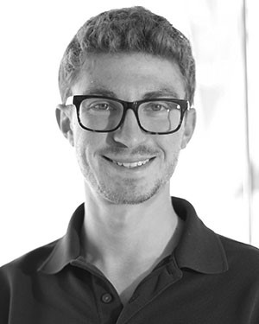**Max L. Olender** (Member, IEEE) was born in Detroit, MI, USA. He received the B.S.E. degree in mechanicalengineering(minorinelectricalengineering) and M.S.E. degree in biomedical engineering from the University of Michigan, Ann Arbor, MI, USA, in 2015 and 2016, respectively. He is currently a candidate for the Ph.D. degree in mechanical engineering at the Massachusetts Institute of Technology, Cambridge, MA, USA. He currently works as a Research Assistant in the Harvard-MIT Biomedical Engineering Center, Cambridge, MA, USA, and serves

as an Associate Editor for the *Journal of Science Policy & Governance*. He previously conducted research at the University of Michigan with the Biomechanics Research Laboratory and the Neuromuscular Lab. He has published his research in the IEEE TRANSACTIONS ON MEDICAL IMAGING and presented work at several international IEEE conferences with peer-reviewed conference proceedings. Mr. Olender is a Student Member of the American Association for the Advancement of Science, Biomedical Engineering Society, and European Society of Biomechanics.

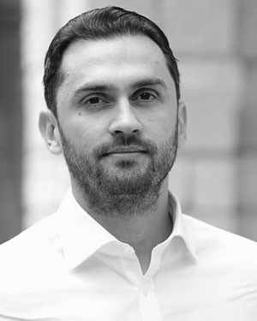**Lambros S. Athanasiou** was born in Ioannina, Greece in 1985. He received the engineering degree from the University of Aegean, Samos, Greece and the Ph.D. degree from the University of Ioannina, Ioannina, Greece, in 2009 and 2015, respectively. In 2019, he concluded a Postdoctoral Research Fellowship at the Massachusetts Institute of Technology, Cambridge,MA,USAandtheBrighamandWomen’s Hospital, Boston, MA, USA. He has authored dozens of research articles, book chapters, and a book. His current research interests include medical image pro-

cessing, machine learning, biomedical engineering, and medical expert systems. Dr. Athanasiou has served as a reviewer for several professional scientific associations and committees.

**Lampros K. Michalis** was born in Arta, Greece in 1960. He received the M.D. degree with distinction from the Medical School, University of Athens, Athens, Greece, in 1984, where in 1989, he was awarded his M.D. thesis with distinction. He has been fully trained in clinical and interventional cardiology in the United Kingdom. Since 1995, he has been with the University of Ioannina Medical School, Ioannina, Greece, where he is a Professor in the Department of Cardiology. His current research interests include interventional cardiology, vibrational angioplasty, in-

travascular imaging, coronary and peripheral artery disease, and bioengineering.

**Dimitris I. Fotiadis** (Fellow, IEEE) was born in Ioannina, Greece in 1961. He received the Diploma degree from the National Technical University of Athens,Athens,Greece,in1985,andthePh.D.degree from the University of Minnesota, Minneapolis, MN, USA, in 1990, respectively, all in chemical engineering. He is currently a Professor of Biomedical Engineering in the Department of Materials Science and Engineering, University of Ioannina, Ioannina, Greece, where he is also the Director of the Unit of Medical Technology and Intelligent Information Systems, and is also an Affiliated Member of the Foundation for Research and Technology Hellas, Institute of Molecular Biology and Biotechnology, DepartmentofBiomedicalResearch.HewasaVisitingResearcherattheRWTH, Aachen, Germany, and the Massachusetts Institute of Technology, Cambridge, MA, USA. He has coordinated and participated in more than 200 R&D funded projects (in FP6, FP7, H2020, and national projects), being the coordinator and technical coordinator in several of them. Prof. Fotiadis is an IEEE EMBS Fellow, EAMBES Fellow, Fellow of IAMBE, member of the IEEE Technical Committee of Information Technology in Healthcare, Editor-in-Chief of IEEE

JOURNAL OF BIOMEDICAL AND HEALTH INFORMATICS,AssociateEditorofIEEE

REVIEWS IN BIOMEDICAL ENGINEERING, IEEE OPEN JOURNAL IN ENGINEERING IN MEDICINE AND BIOLOGY, and *Computers in Biology and Medicine*. His current research interests include multiscale modeling of human tissues and organs, intelligent wearable/implantable devices for automated diagnosis, processing of big medical data, machine learning, sensor informatics, image informatics, and bioinformatics. He is the recipient of many scientific awards including the one by the Academy of Athens.

**ElazerR.Edelman**wasborninNewYork,NY,USA. He received B.S. degrees in bioelectrical engineering and in applied biology and the M.S. degree in electrical engineering and computer science from the Massachusetts Institute of Technology (MIT), Cambridge, MA, USA, in 1978 and 1979, respectively. He received the M.D. degree from Harvard Medical School, Boston, MA, USA in 1983, and the Ph.D. degree in medical engineering and medical physics from MIT in 1984. He is currently the Edward J.

PoitrasProfessorinMedicalEngineeringandScience

at MIT, Professor of Medicine at Harvard Medical School, and Senior Attending Physician in the coronary care unit at the Brigham and Women’s Hospital in Boston, MA, USA. He is also Director of MIT’s Institute for Medical Engineering and Science and Clinical Research Center, as well as the Harvard-MIT Biomedical Engineering Center. Prof. Edelman is a fellow of the American College of Cardiology, American Heart Association, Association of University

Cardiologists, American Society of Clinical Investigation, American Institute of Medical and Biological Engineering, American Academy of Arts and Sciences, National Academy of Inventors, Institute of Medicine/National Academy of Medicine, and National Academy of Engineering.